Experiment

**Design a smartphone controlled device**

**Circuit diagram:**

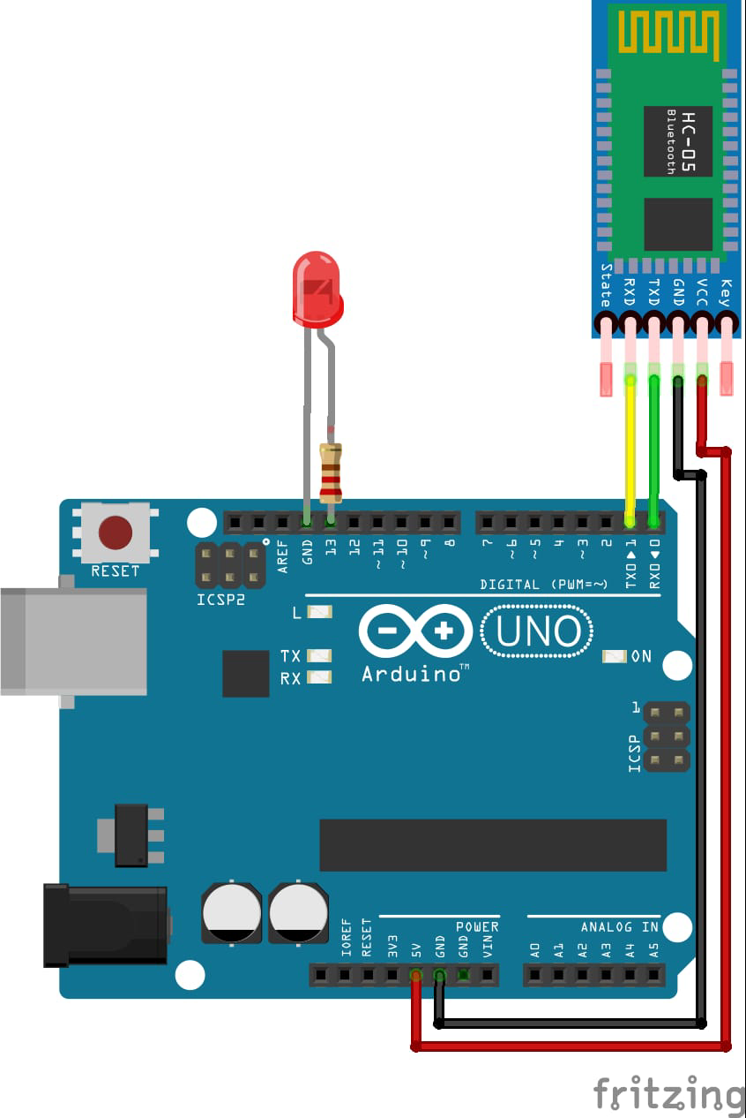

**Theory**

### CONCEPT USED:

1. By using kirchoff’s voltage law
2. &
3. By using kirchoff’s current law
4. Wireless technology
5. Bluetooth interfacing

## LEARNING AND OBSERVATIONS:

1. Connections in Breadboard and wiring.
2. How to control arduino and its coding.
3. Use of multimeter for continuity.
4. Proper use of bluetooth

**OBSERVATION:**

1. Controlling of devices through a remote
2. Relation between software and hardware.
3. Varation of frequency

# PROBLEMS & TROUBLESHOOTING:

1. To select the right port and type of arduino
2. To check the loose connections
3. To check the connections according to the codes
4. To check the continuity of the circuit
5. To check the flow of current in the circuit
6. Errors in code
7. Setting up right connections
8. Display in proper order
9. Pinmodes of devices

# PRECAUTIONS:

1. Do not connect arduino till the circuit is complete
2. Do not connect leds without a variable resistor
3. Proper Bluetooth module

# OUTCOMES:

1. Making of wireless controlled devices by bluetooth module.
2. Proper use of Arduino and breadboard

**Created By-**

**Name: RISHABH GUPTA**

**ROLL NO: 19BCS3792**

**Stream: CSE(BD1 B)**

**University: CHANDIGARH UNIVERSITY**